Knee joint biomechanics

By Dr. Maitri Shukla

Open pack position -25degree flexion

Close pack position –full extention

Capsuler pattern –Either flxion or extention

The knee plays a primary role in loweringand elevating body weight during sitting, squatting,and climbing.

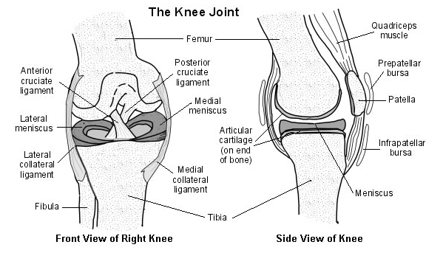

**Functions OF PATTELA**

**1.** Improve the efficiency and increase torque of theknee extensors throughout the knee’s range ofmotion;

**2.** Centralize the forces of the four quadriceps musclesinto one concerted direction of pull;

**3.** Provide a smooth gliding mechanism for thequadriceps muscle and tendon to reduce compressionand friction forces during activities such asdeep knee bends;

**4.** Contribute to the overall stability of the knee

**5.** Provide bony protection from direct trauma to thefemoral condyles when the knee is flexed.

***Menisci***

The menisci provide the knee joint with important properties. The fibrocartilaginous menisci are attached to the tibia.

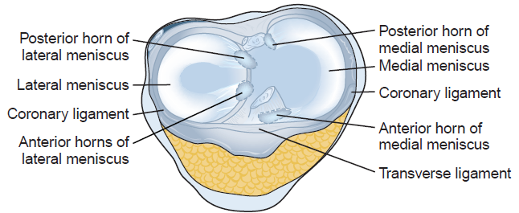

The menisci serve several purposes for the kneejoint:

**1.** The menisci deepen the knee joint and thereby add stability to it.

**2.** The menisci absorb and distribute forces ofimpact.

**3.** The menisci are able to distribute forces of impactby increasing the surface

4. The menisci promote joint lubrication by spreading a film of synovial fluid over the articular surfaces.

**5.** The menisci prevent the joint capsule from intruding into the joint space

Surgical removal of the menisci decreases the surface area and causes pressure to increase on the femoral and tibial condyles, which may lead to later osteoarthritis.

***Ligaments and Capsule***

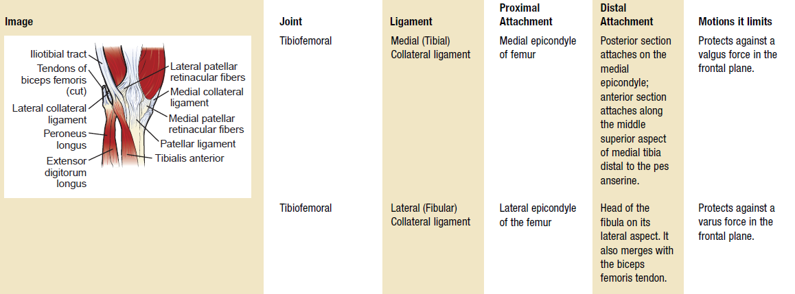

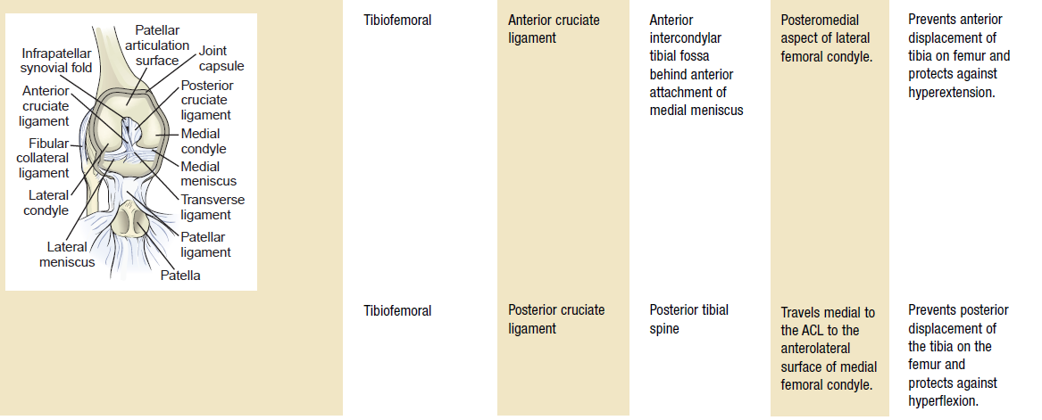

***Kinematics of the Tibiofemoral Joint***

The knee joint possesses two degrees of freedom: flexion-extension and axial rotation.

Flexion -0 to 125

End feel –soft

Extention -125 to 0

End feel –firm

when you flex your knees to sit down, your femur rolls backward; however, the surface of the tibia is used up during this rolling maneuver before the knee is done flexing, so the femur must glide forward to a new location on the tibia so it can continue rolling backward to allow your knee to flex sufficiently to allow you to sit in the chair. When you stand to get out of the chair, your knees perform a reverse maneuver during closed chain activities, starting a forward roll of the femur on the tibia and then gliding posteriorly as the femoral condyles run out of space on the tibia but need to continue to roll forward until you are fully standing. **Axial Rotation**

Axial rotation occurs in the transverse plane when the knee is flexed. When the knee is fully extended, themedial and lateral collateral ligaments are relatively tense, contributing to the stability of the joint.

**Terminal Rotation of the Knee**

when the knee moves into extension, the tibia laterally rotates about 20°on the fixed femur. This motion occurs in the last 20°of knee extension and is called **terminalrotation of the knee,** or the **screw home mechanism**.

As the tibial condyles move on the femoral condyles during open chain knee extension, the motion on the shorter lateral femoral condyle is completed before the motion on the medial femoral condyle is completed. Since the available surface area of the lateral femoral condyle is used before movementon the medial femoral condyle is finished, pivoting of the tibia on the femur occurs between the lateralcondyles to allow the medial aspect of the knee to complete its motion. This pivoting produces passive lateral rotation of the tibia on the femur in the last 15° of extension. When the knee extends during closed chain activities, motion of the femur rather than the tibia occurs; as with open chain activities, movement of the shorter lateral femoral condyle is completed before that of the medial femoral condyle but now the femur rotates medially on its lateral condyle to allow full terminal extension to occur at the knee. Unlocking the knee in either an open or closed chain produces reverse rotation motions to those of their respective terminal knee extension function.

***Arthrokinematics of the Tibiofemoral Joint***

The concave tibial surface slides or glides in the same direction as the roll, or joint motion, when the tibia moves on the femur during open kinetic chain activity. Therefore, when the tibia rolls forward on the femur into extension, it also glides forward; likewise, when the tibia rolls backward as the knee moves into flexion, the tibia glides posteriorly. When joint motion occurs in the closed kinetic chain as during a sit-to-stand activity, the convex femoral condyles move on concave tibial condyles.

During closed chain motions, then, as the knee moves into extension, the roll of the femur on the tibia, or joint motion, is anterior (forward) while the glide is posterior. Reverse directions of movement of the roll and glide occurs when the weight-bearing knee moves into flexion: the roll of the femur is posterior and the glide is anterior.

**Patellofemoral Joint**

**Close pack position –knee flexion**

**Open pack position –knee extention**

The patella lies within the common tendon of the quadriceps, which extends above and on the sides ofthe patella as well as attaching to it. From the apex of the patella, the patellar ligament is the continuationof the quadriceps tendon and extends to the tibial tuberosity.

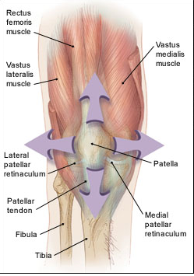

When the knee is in full extension, patellarstability relies primarily on soft tissues which surround it. The extensor, or quadriceps, mechanism actively stabilizes the patella on all sides and guides the motion between the patella and the femur. From 20° to 0°, the primary responsibility of the vastusmedialis oblique (VMO) muscle is to serve as a dynamic stabilizer of the patella

When knee flex the lateral structure moves posteriorly and create lateral and tilting forces on thepatella. Therefore, the patella is affected by both static (fascia) and dynamic (muscle) forces. In essence, the minimal congruency between the posterior patella and anterior femoral condyles forces the patella to rely on the soft tissues for its stability.

***Kinematics of the Patellofemoral Joint***

The patellofemoral joint is intimately connected to the tibiofemoral joint, not only in anatomy but also infunction.

**Patellofemoral Contact**

As the knee moves from extension into flexion, the patella and femur move relative to one another—which moves depends on whether it is an open or closed chain motion.

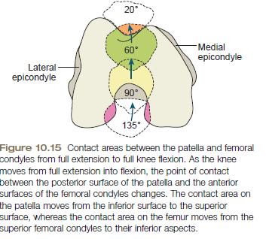

The apex of the patella lies near the tibiofemoral joint margin when the knee is fully extended.

If the patella lies more distally on the femur, it is a **patella baja**; if it lies more proximally, it is a **patella alta.**

***Arthrokinematics of the Patellofemoral Joint***

The posterior patellar surface is concave and moves on a convex femoral surface. Therefore, the patellofemoral joint abides by the concave-on-convex principle. The resting position of the patellofemoral joint is full extension and the close-packed position is flexion. As the knee flexes and extends, the patella glides within the intercondylar groove. As the knee moves into flexion, the patella glides inferiorly, and as the knee extends, the patella glides superiorly. Patellar rotation, medial-lateral shifting, and mediallateraltilting occur during knee flexion and extension. The specific timing and occurrence of each of thesemotions is yet to achieve.

**Q Angle**

An anterior view of the extended knee reveals an angle, open laterally, between the shafts of the femur and the tibia. This is the quadriceps angle, or **Q angle**

The size of the angle is variable for both sexes; studies place the range of values for men from about10° to 14° whereas measures for women are larger and range from about 15° to less than 23°.Women have been shown to have consistently larger Q angles than men.

An excessive Q angle is referred to as **genu valgum,** or knock knee.

Conversely, if the Q angle is closer to 0° or the knee joint is convex laterally, the alignment is referred to as **genuvarum,** or bowleg. Q angles have been found to be greater in those individuals reporting patellofemoral pain than innonpainful groups.

**Muscles of knee joint**

**Knee Extensors**

The quadriceps femoris muscle group extends the knee and includes four muscles: rectus femoris, vastuslateralis, vastusmedialis, and vastusintermedius. The vastusmedialis lies in a position medial to the rectus femoris.

Vastusmedialis was responsible for the last 20° to 30° of knee extension.

The medially directed forces of the VMO may also counteract the laterally directed forces of the vastuslateralis to prevent lateral displacement of the patella in the trochlear groove.

**Knee flexors**

The primary muscles are the hamstrings (biceps femoris, semitendinosus, and semimembranosus)

The hamstrings also serve to stabilize the knee by restricting an anterior glide of the tibia on the femur.

tendons of the sartorius, gracilis, and semitendinosus are on the anterior medial surface of the tibia below the medial condyle, forming the **pesanserinus**.

**Muscles acting on knee joint**

1. **Active insufficiency** occurs when a multijoint muscle shortens but is unable to shorten sufficiently to allow full joint motion at all the joints it crosses;

Ex.Hipextention in standing with knee flexion(hamstring)

1. **Passive insufficiency** occurs when a multijoint muscle is unable to stretch sufficiently to allow both joints it crosses to fully shorten;

Ex.Hipextention in standing with knee flexion (rectus femoris )

straight leg raise (SLR)(passive insufficiency of hamstring )

3) **Optimal sufficiency** occurs when opposing muscles at one end where a multijoint muscle attaches,

positions that joint to allow optimal function of the multijoint muscle.

Ex.hip knee flexion this combination to our advantage during walking, running, and hopping activities.Ex.knee extension with hip extension.

Joint Forces

**Tibiofemoral Joint Forces**

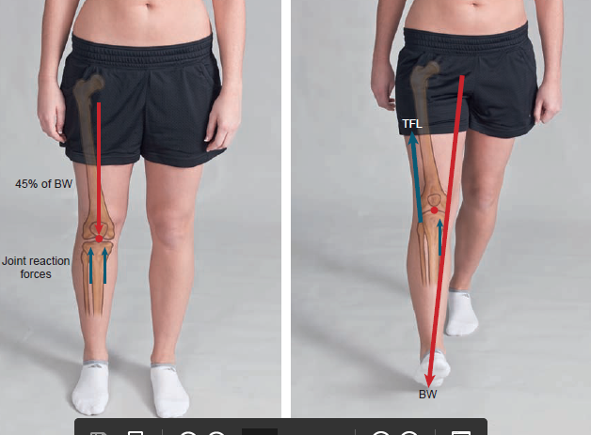

These tibiofemoral compressive forces increase with stair climbing, running, jumping, and squatting.During normal walking, tibiofemoral compression forces reach almost four times body weight with the majority of that force (60%) borne by the medial compartment.

As the weight gain increases(obesity), the individual can be seen to shift the trunk more and more laterally with each step in walking. Due to this abductors force is reduce ,along with this weight bearing vector shifts laterally due to asymmetrical condyler pressure. In time, these abnormal forces can lead to a knock-knee deformity, cartilaginous and meniscal thinning and destruction, and osteoarthritis

**Patellofemoral Joint Forces**

One of the purposes of a pulley is to change the direction or angle of a force. The patella may be thought of as a pulley for the quadriceps since it does change the angle of force of the quadriceps.

Throughout the range of motion, the knee loses 15% to 30% strength following a **patellectomy**

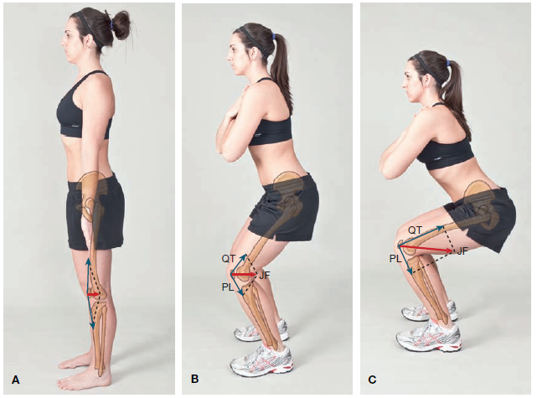

Patellofemoral compressive force in open kinetic chain activities is greatest at 0° and decreases as the knee moves to 90°; in a closed kinetic chain motion, patellofemoral stress is greatest at 90° and decreases as the knee moves into full extension.

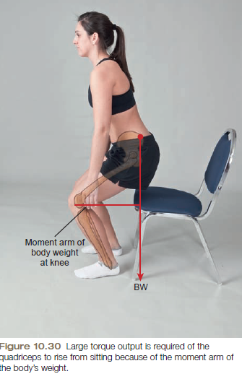

As the knee moves near extension, the quadriceps’s ability to produce force is significantly diminished.

Functionally, the greater torque output of the quadriceps muscle at the 50° to 60° position coincides with a need for large torques in elevation of the body, as in rising from a chair and climbing. In these activities, a perpendicular line from the center of gravity of the body falls well posterior to the knee axis and, therefore, exerts a large resistance torque for the quadriceps to match.

Knee joint pathomichanics

Knee osteoarthritis is often seen in older adults and is particularly common in women. This progressive erosion of articular cartilage may be initiated by a previous traumatic joint injury, obesity, malalignment, instability, or quadriceps muscle weakness, to name just a few of the many suspected contributors to the development of osteoarthritis.

Genu valgum- An excessive Q angle is referred to as **genu valgum,** or knock knee.

Genu varum-refuced Q angle is refferedas genu**varum,** or bowleg.

Q angles have been found to be greater in those individuals reporting patellofemoral pain than in nonpainful groups.

patella lies more distally on the femur, it is a **patella baja**.

patella lies more proximally, it is a **patella alta.**

***liotibial (IT) band friction syndrome***is irritation of the IT band as it passes over the lateral femoral condyle.

Contributing factors could be tight tensor fasciae latae or tight gluteus maximusBecause the IT band attaches to the patella and lateral retinaculum, it may cause anterior knee pain.

***Prepatellar bursitis****,* also known as housemaid’s knee results from prolonged kneeling or recurrent minor trauma to the anterior knee. The cause of injuries to these structures may be either a direct blow or prolonged compressive or tensile stresses. Bursitis is common after either blunt trauma or repetitive low-level compressions, which can irritate the tissue. When inflamed there may be restricted motion due to the swelling and pain caused by direct pressure or pressure from the patellar tendon.

**Ligaments injury**

**Anterior Cruciate Ligament**

Anterior cruciate ligament (ACL) injuries occur from both contact and noncontact mechanisms. The most common contact mechanism is a blow to the lateral side of the knee resulting in a valgus force to the knee. This mechanism can result in injury not only to the ACL but to the medial collateralligament (MCL) and the medial meniscus as well.

The most common noncontact mechanism is a rotational mechanism in which the tibia is externally rotated on the planted foot. Literature supports that this mechanism can account for up to 78% of all ACLinjuries.

The second most common noncontact mechanism is forceful hyperextension of the knee.

**Posterior Cruciate Ligament**

The posterior cruciate ligament (PCL) is most commonly injured by a forceful blow to the anterior tibia while the knee is flexed, such as a blow to the dashboard or falling onto a flexed knee.

**Medial Collateral Ligament**

Isolated injuries to the medial collateral ligament (MCL) can occur from valgus forces being placed across the medial joint line of the knee.

**Lateral Collateral Ligament**

Injuries to the lateral collateral ligament (LCL) are infrequent and usually result from a traumatic varus force across the knee. It is not uncommon that more than one ligament, joint capsule, and sometimes the menisci are damaged as the result of a single injury.

**MENISCAL TEARS:**

The medial meniscus is injured more frequently than the lateral meniscus. Insult may occur when the foot is fixed on the ground and the femur is rotated internally, as when pivoting, getting out of a car, or receiving a clipping injury.

An ACL injury often accompanies a medial meniscus tear.

Lateral rotation of the femur on a fixed tibia may tear the lateral meniscus. Simple squatting or trauma may also cause a tear.